Dear ACR+ member,

The Catalan Waste Agency is involved in a project related to circular economy in EMAS registered organizations. The objective of the project is to assess which materials currently considered as “waste” by the companies/business could be reused by charities, schools, artists and others in order to extend the life of materials/objects and optimize resources.

One of the challenges we are facing is that for years it has been considered “waste” everything that comes out from a company and it’s not a “product”. This view limits the capacity of reusing materials, because charities are not “authorized waste managers”.

We would like to know about how do you deal with this issue in your country, and therefore we kindly ask you to help us by answering 5 questions that you’ll find in the attached file. In case you prefer to respond by phone, let me know (pchiva@gencat.cat) and we will agree on a date and time to make the call in the following days.

Please send your answers to the questionnaire to pchiva@gencat.cat, if possible by the end of June.

Thank you in advance for your collaboration.

Pilar Chiva
Catalan Waste Agency

- Are companies allowed in your country to donate materials and objects to charities, schools, artists and other interested parties?
- If yes, under which conditions?
NO specific condition is required, just common sense and avoid donating dangerous materials that could cause harm to people or to the environment.
The company has to keep records about the quantities and donated materials - an internal record is enough (available for review / inspection of the administration).
The company has to keep records about the quantities and donated materials - a specific record is required by the authorities (a specific contract, template, etc.).
The company has to previously report the donation to the competent authority and then, if allowed, it can donate it.
Other: (please explain).
- If not, why?
It cannot be done; the law definitely forbids this option.
It’s not clearly defined by the law, but it cannot be done because the enforcement authority interprets that all outputs from a company are considered waste if they are not a product and they cannot be given to a non-authorised waste manager.
Other: (please explain).
- Which of the following materials/objects or group of materials/objects could be donated and are not considered waste accordingly to the interpretation of waste law and your understanding of the local situation? (Please mark with an “X”)

Furniture (tables, chairs lockers, etc.) |  | Wood (boxes, panels, sticks, pallets, etc.) in good conditions (of course, uncontaminated wood)
Usable electronic devices such as PCs, printers, telephones, and other office machines |  | Clean cardboard containers, cardboard cores, etc.  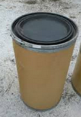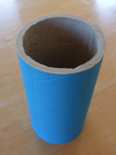
Clean plastic containers, boxes, drawers, rings, panels, etc.  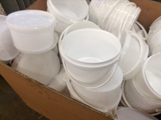 |  | Ice bags (those used in the portable picnic fridges)  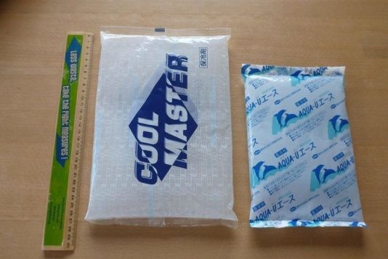
Construction materials such as pieces of pipe, cement in good conditions, paint, metal net, doors, windows, and other materials that can be used. |  | Others:

Or make your own list of materials already admitted to donation:

- Are you aware of the same problem in your country/region and how the administration is facing it? If yes, could you please provide us some inputs? It could be of great interest to us to get, if available, the legislation which allows or defends the possibility of reuse of materials & objects.

